CS 305 Module Five Coding Assignment Checksum Verification Template

Amy Marquis

Instructions
Using the instructions from the Module Five Coding Assignment Checksum Verification Guidelines and Rubric, replace the bracketed text with the relevant information in your own words.

Algorithm Cipher

The SHA-256 hashing algorithm was selected for its robust security features and efficiency in generating fixed-length hashes. This algorithm is part of the SHA-2 family and is widely recognized for its resistance to collision attacks, making it an excellent choice for applications requiring data integrity and security.

Justification

SHA-256, a member of the SHA-2 family, is approximately 60% slower in performance compared to MD5, which is often favored for its speed. However, despite this slower performance, SHA-256 offers a significantly higher level of security compared to SHA-1, making it a more robust choice for data integrity and cryptographic purposes. For most applications that do not require extremely high levels of security, the 256-bit key length provided by SHA-256 is generally considered adequate. In many non-critical systems, this level of encryption can effectively protect against common vulnerabilities. Consequently, there is often no compelling reason to opt for the even slower alternatives, such as SHA-384 or SHA-512, unless the specific requirements of a system demand an additional layer of security.

Generate Checksum

I have no idea what I am doing wrong, but I have tried to get this to run for 3 days and my brain is fried. I have searched online, and asked friends.. but this is what I have ( with it being Thanksgiving it’s harder)

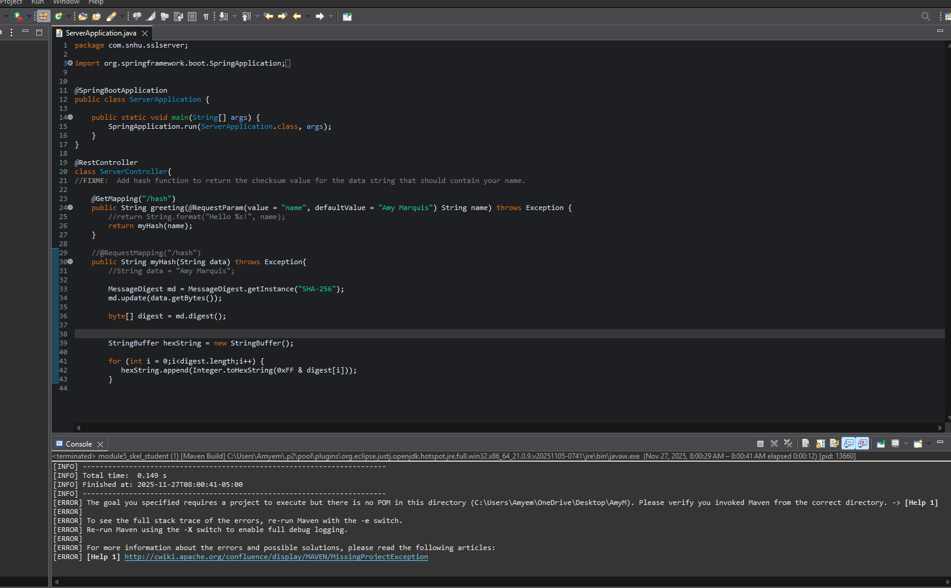

Verification

Insert a screenshot below of the web browser with your unique information.

Could not get it to work…

My computer keeps giving me the host is not available
- Then use your web browser to connect to the RESTful API server. This action should show your first name and last name as the unique data string in the browser, the name of the algorithm cipher you used, and the checksum hash value.

I have spring boot installed and I can’t get it to run the script
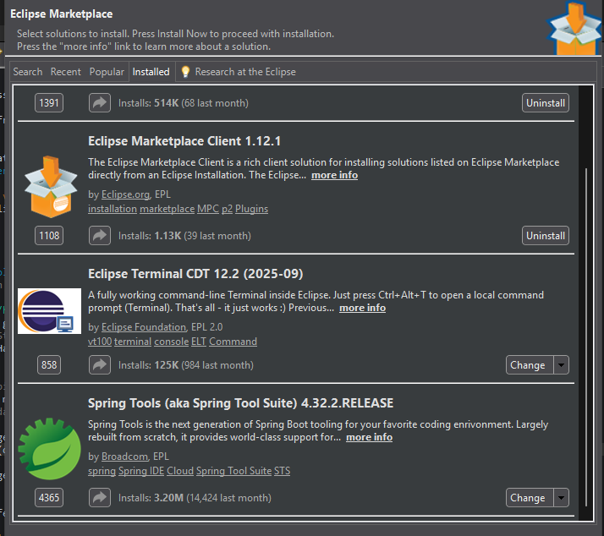

I can’t even get the local Hash to work



